# **Name: Sharvayu Zade**

# **Sec: B(B2)**

# **PRN: 23070521135**

# 

# **Practical 6 Part 1: String Functions & Operations in JavaScript**

## 

## **Introduction**

Strings are one of the most fundamental data types in JavaScript. They are used to store and manipulate textual data such as names, messages, file paths, etc. This lab will teach students how to:

* Work with built-in JavaScript string functions.
* Perform common string operations like searching, splitting, replacing, trimming, and extracting.
* Write practical code for solving real-world string-related problems.

### 

### **Basic Properties of Strings**

Strings are **immutable** in JavaScript.  
Example:  
let s = "Hello";

s[0] = "Y";

console.log(s); // Output: Hello (no change!)

### 

### **Common String Methods with Syntax & Explanation**

| **Method** | **Syntax** | **Description** |
| --- | --- | --- |
| length | str.length | Returns the number of characters. |
| charAt() | str.charAt(index) | Returns character at a specific index. |
| indexOf() | str.indexOf(value) | Finds the first occurrence of a substring. |
| lastIndexOf() | str.lastIndexOf(value) | Finds the last occurrence of a substring. |
| slice() | str.slice(start, end) | Extracts part of a string. |
| substring() | str.substring(start, end) | Similar to slice but cannot accept negative indexes. |
| split() | str.split(separator) | Splits into an array using a separator. |
| replace() | str.replace(find, replace) | Replaces first occurrence of a value or regex. |
| toUpperCase() | str.toUpperCase() | Converts to uppercase. |
| toLowerCase() | str.toLowerCase() | Converts to lowercase. |
| trim() | str.trim() | Removes whitespace from both ends. |
| includes() | str.includes(value) | Checks if a substring exists. |

**Syntax and Worked Examples**

### **Example 1: Finding the first occurrence using indexOf()**

let text = "Welcome to JavaScript Lab";

let pos = text.indexOf("JavaScript");

console.log(pos); // Output: 11

**Explanation:**The substring "JavaScript" starts at position 11 (0-based index).

### 

### **Example 2: Splitting a sentence using split()**

let sentence = "HTML,CSS,JavaScript,Python";

let parts = sentence.split(",");

console.log(parts);

// Output: ["HTML", "CSS", "JavaScript", "Python"]

### **Example 3: Replacing text using replace()**

let quote = "I like cats";

let newQuote = quote.replace("cats", "dogs");

console.log(newQuote); // Output: I like dogs

### **Example 4: Extracting substring using slice()**

let word = "JavaScript";

console.log(word.slice(0, 4)); // Output: Java

### **Example 5: Counting vowels in a paragraph**

function countVowels(str) {

let vowels = "aeiouAEIOU";

let count = 0;

for (let char of str) {

if (vowels.includes(char)) count++;

}

return count;

}

console.log(countVowels("Hello World")); // Output: 3

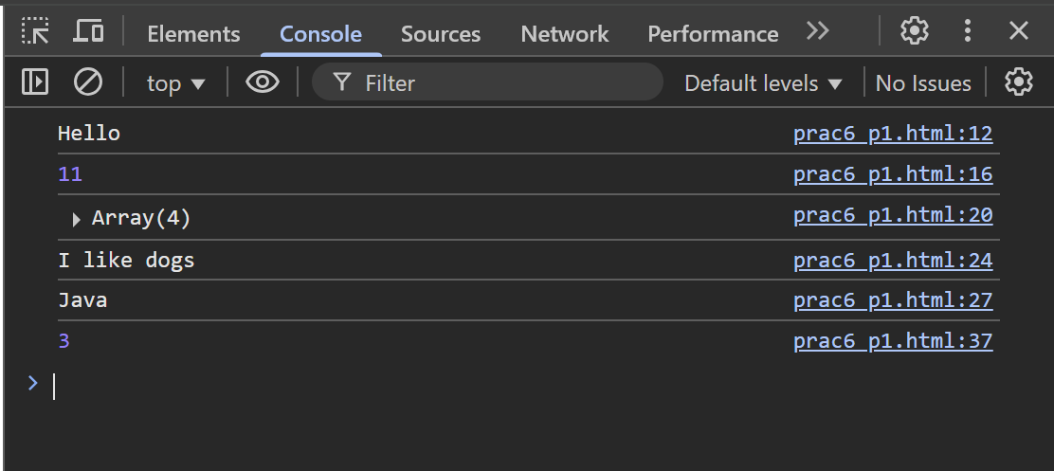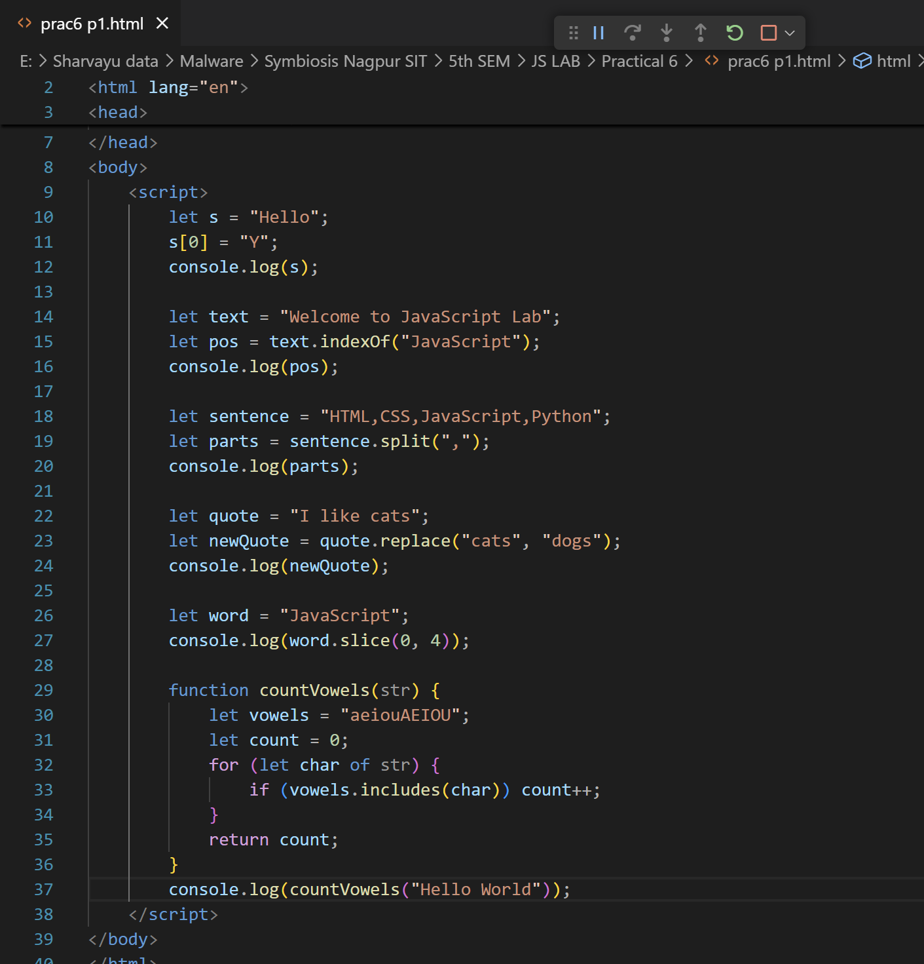

### 

### **Task 1: Name Formatter**

* Input: " jOhN doE "
* Output: "John Doe"
* Steps:
  1. Remove extra spaces using trim().
  2. Convert first character to uppercase and the rest to lowercase using charAt() and slice().

### **Task 2: Reverse a String**

* Input: "JavaScript"
* Output: "tpircSavaJ"

**Hint:**

let str = "JavaScript";

let reversed = str.split("").reverse().join("");

console.log(reversed);

### **Task 3: Validate Email Address**

* Use regex /^[A-Za-z0-9._%+-]+@[A-Za-z0-9.-]+\.[A-Za-z]{2,}$/

Example:  
 let email = "student@example.com";

console.log(/^[A-Za-z0-9._%+-]+@[A-Za-z0-9.-]+\.[A-Za-z]{2,}$/.test(email));

// Output: true

### **Task 4: Replace Multiple Spaces with Single Space**

* Input: "JavaScript is fun"
* Output: "JavaScript is fun"
* **Hint:** Use replace() with regex /\s+/g.

### **Task 5: Word Count**

* Input: "Hello world, welcome to the JavaScript lab"
* Output: 7
* **Hint:** Use split(" ") and count array length.

